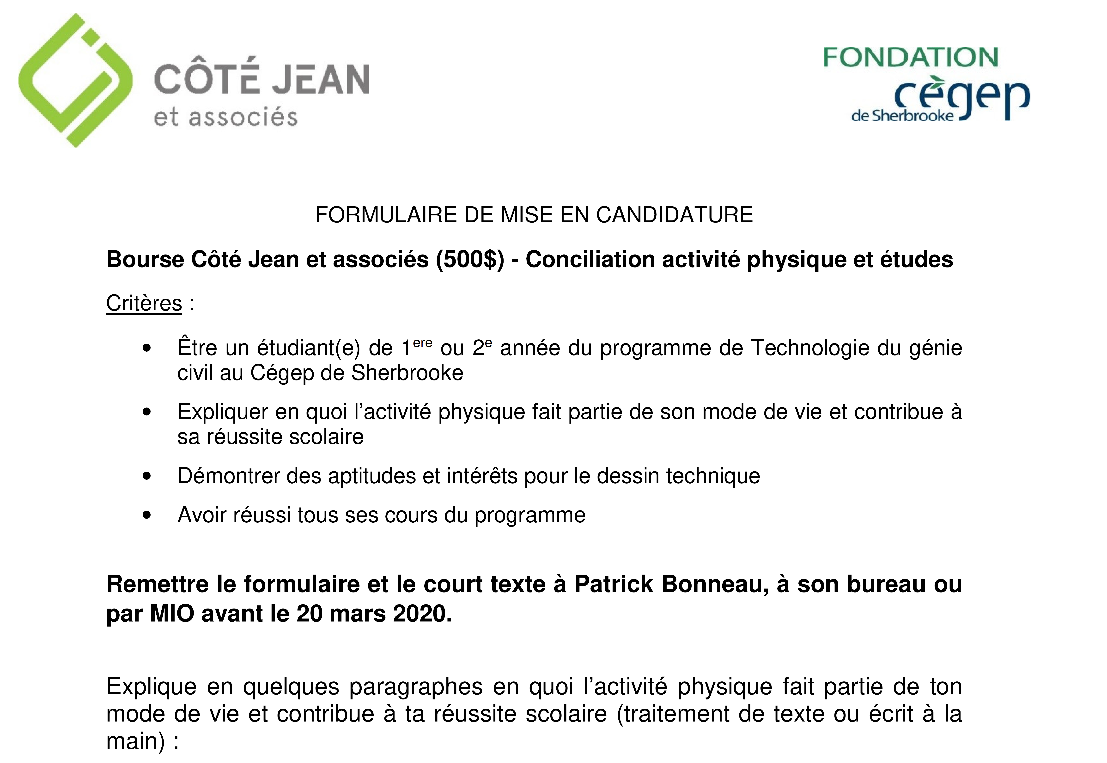
Nom du candidat : ___________________________________

________________________________________________________________________________________________________________________________________________________________________________________________________________________________________________________________________________________________________________________________________________________________________________________________________________________________________________________________________________________________________________________________________________________________________________________________________________________________________________________________________________________________________________________________________________________________________________________________

________________________________________________________________________________________________________________________________________________________________________________________________________________________________________________________________________________________________________________________________________________________________________________________________________________________________________________________________________________________________________________________________________________________________________________________________________________________________________________________________________________________________________________________________________________________________________________________________________________________________________________________________________________________________________________________________________________________________________________________________________________________________________________________________________________________________________________________________________________________________________________________________________________________________________________________________________________________________________________________________________________________________________________________________________________________________________________________________________________________________________________________________________________________________________________________________________________________________________________________________________________________________________________________________________________________________________________________________________________________________________________________________________________________________________________________________

